Google Workspace and Microsoft 365 are both leading cloud-based productivity suites that offer a range of applications and services for businesses and individuals.

Google Workspace vs. Microsoft 365

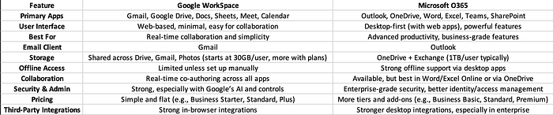

# **✅ Top Advantages of Switching to Office 365**

Familiarity with the Microsoft Ecosystem

Full-Featured Desktop Apps

Advanced Security & Compliance

Enterprise-Grade Email with Outlook

Microsoft Teams Integration

More Powerful File Management

Hybrid Environment-Friendly

More Business App Integrations

*O365 has centralized management through the M365 Admin Center, simplifying administrative and user tasks.*

# **Manually Migrate from Google Workspace to Office 365**

Before we start the procedure, ensure you have following prerequisites:

M365 Exchange Global Admin Account Access

Super Admin Account Access in Google Workspace

Step 1: Adding Office 365 Domain and Users

Step 2: Create a Migration Batch to Migrate Google Workspace to Office 365

Step 3: Updating MX Records to Migrate Email from Google Workspace to Office 365

# **Step 1: Adding Office 365 Domain and Users**

For Domain:

Log in to the Microsoft 365 Admin Center and click Settings → Domain.

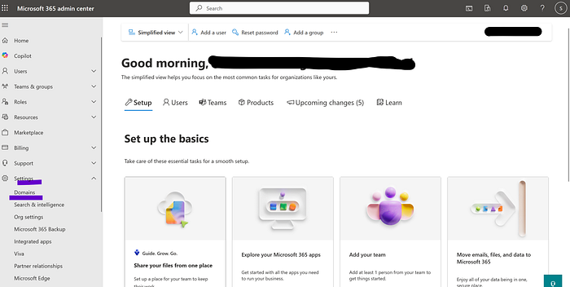

Hit + Add Domain, enter a name, and click Use this, Domain.

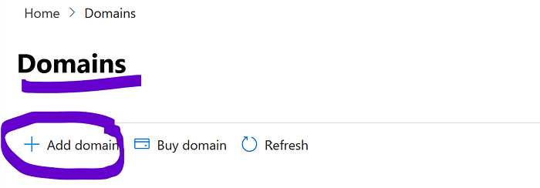

Then, verify your domain → Verify → Continue → Done.

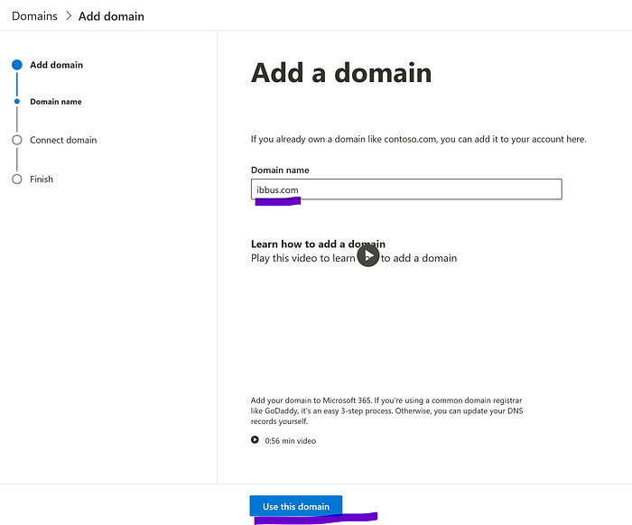

Verify your domain and add only the TXT record.

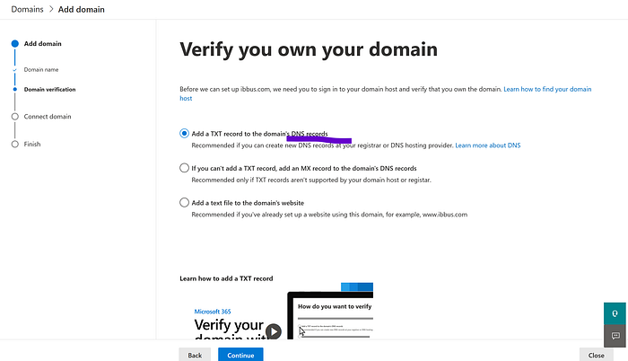

Note: verify the records.

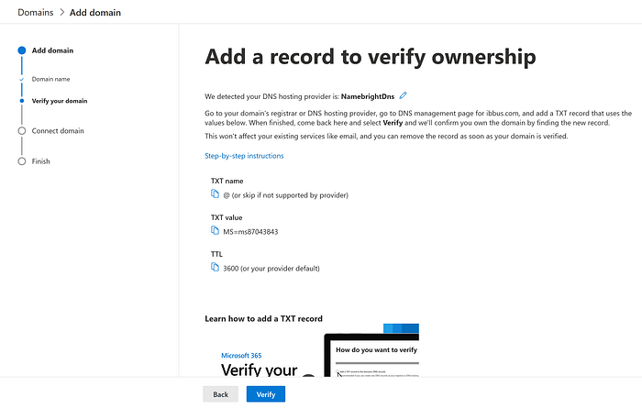

It automatically redirects to the hosting platform, i.e., GoDaddy, and verifies the domain. Finally, it shows health.

Zoom image will be displayed



**Note: Only verify the domain by adding TXT records and not by updating the MX records.**

For Users:

In the M365 Admin Center, press Users and select Active Users.

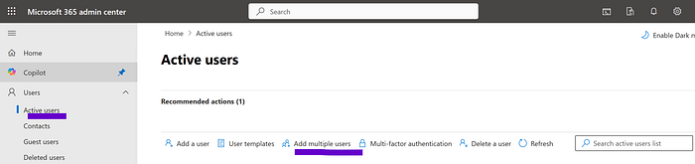

Click Add a User or Add multiple Users and provide the required details.

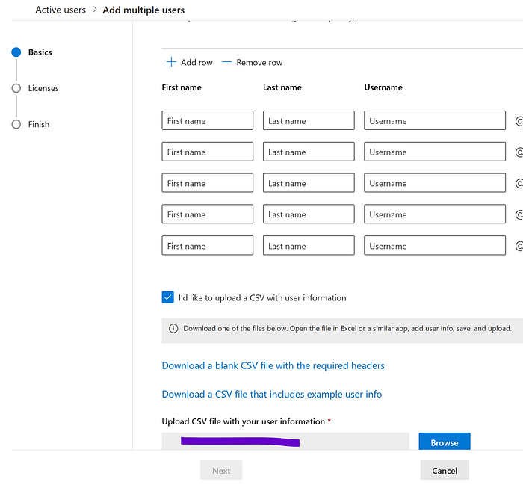

Hit Next, choose a location, and assign licenses. Tap Next.

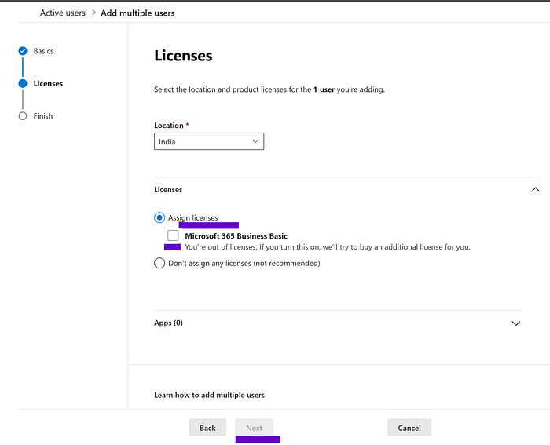

Assign user roles (optional), click Next, and hit Finish → Close.

Further, create a CSV file with Username (source email) and Email Address (destination) fields.

# **Step 2: Create a Migration Batch to Migrate Google Workspace to Office 365**

Open the Exchange Admin Center and tap Migration → Add Migration Batch.

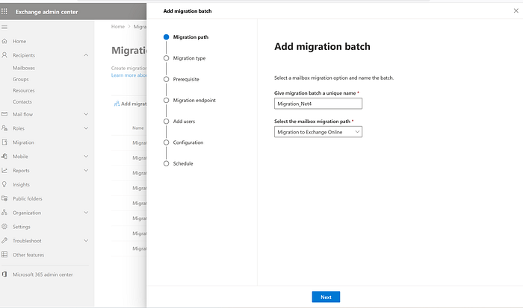

Click Next, select the migration type → Google Workspace (Gmail) migration.

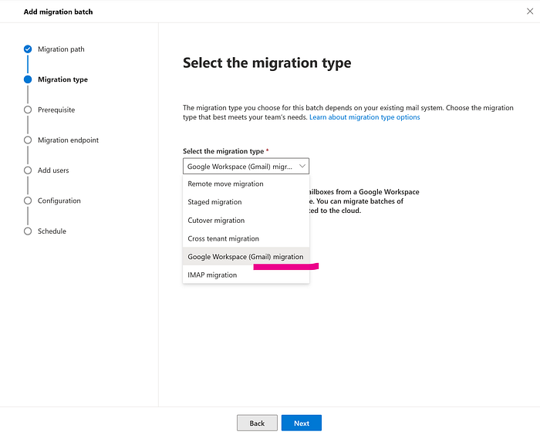

If you click Start, the process automatically creates a project, a service account, and APIs, and adds a Gmail account. But let’s create a manually.

Click Next.

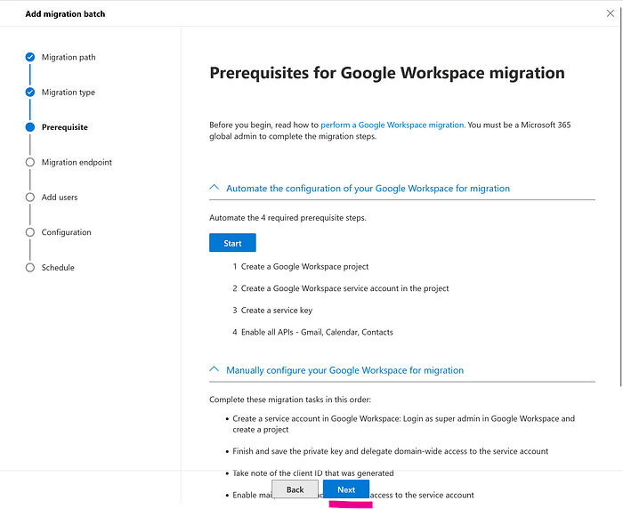

Create a migration endpoint

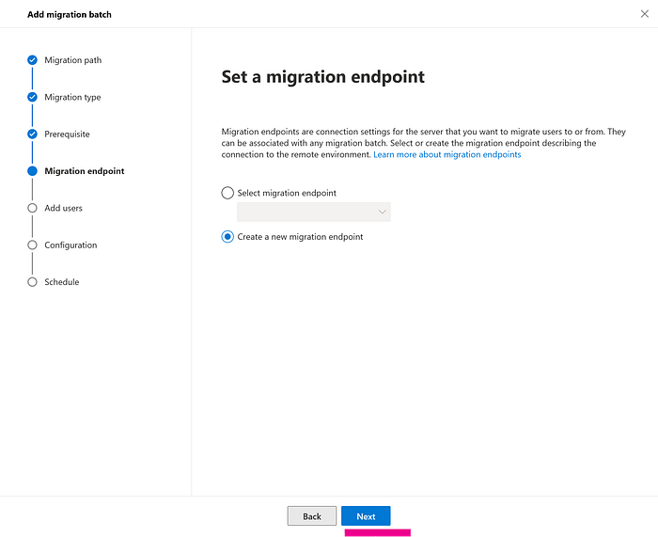

Enter concurrent & incremental sync. At the same time, how many IDs sync?

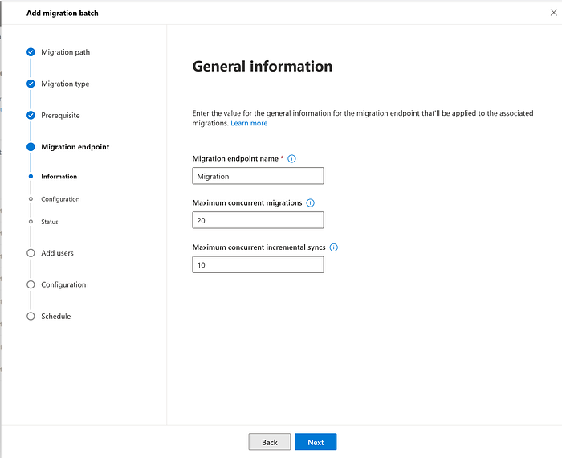

Enter the Gmail admin account IDs and add the JSON file. Where do we get JSON?

See step 3, Gmail account service account JSON key import.

Upload a JSON file. Once a service account is created in Google Workspace, a JSON file is generated.

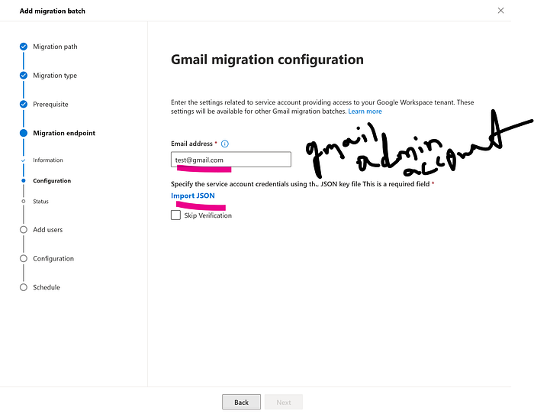

Upload the user list in a CSV file. So, I added 20 IDs.

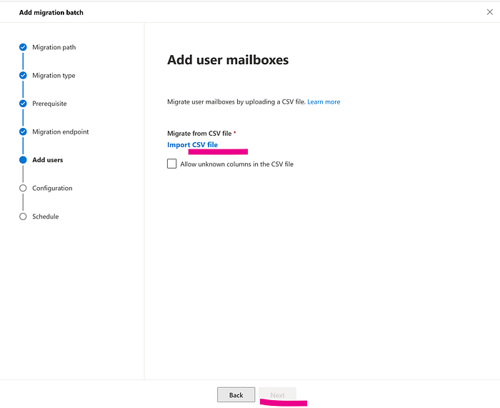

Enter a target delivery domain.

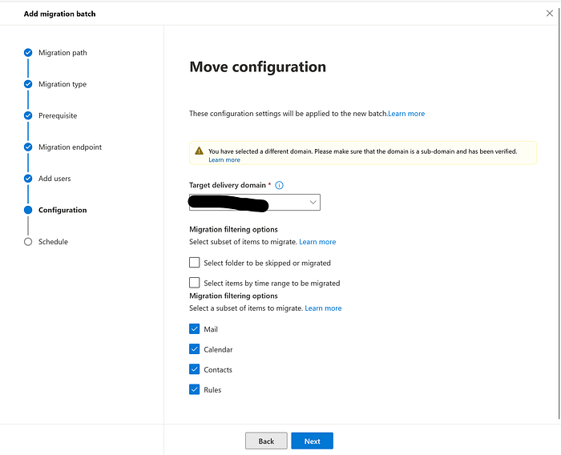

Schedule batch migration.

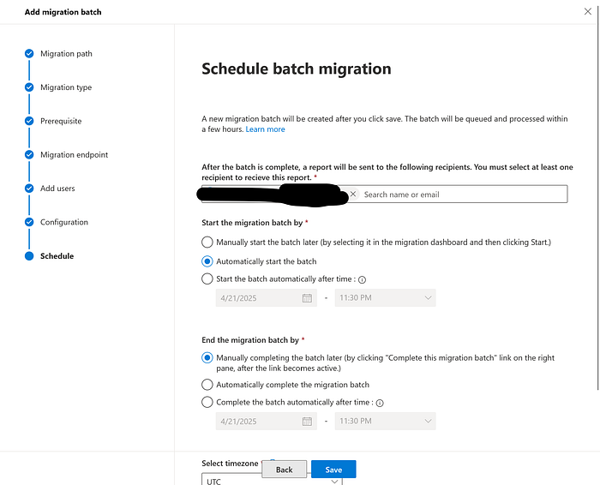

At last, in the Schedule Batch Migration tab,

Select an email address to get the report.

Pick Automatically Start and End the Batch as Migration Batch Fields

Set a time zone and hit Save → Done.

Click Save and Next.

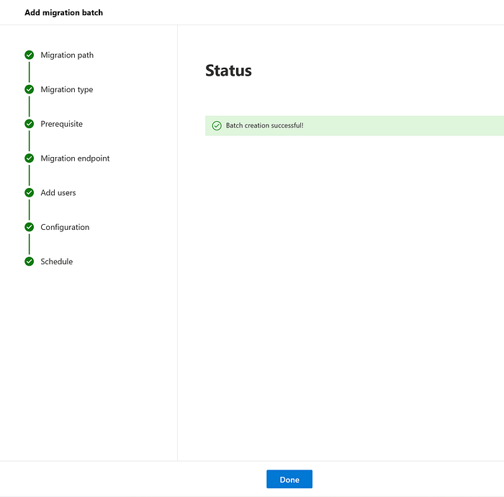

Successfully created the batch. It automatically starts the process.

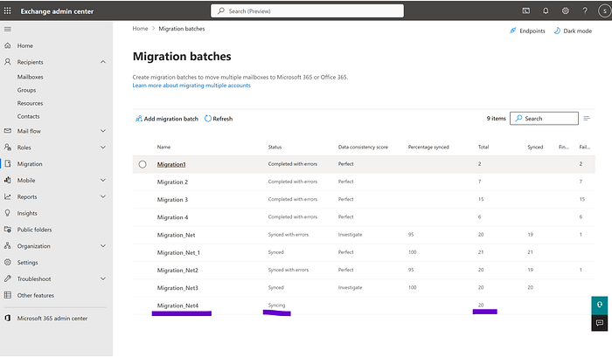

The syncing process has started.

Workspace for migration.

Later, configure the following:

Creating a [**Google Service Account**](https://console.cloud.google.com/projectselector2/iam-admin/serviceaccounts?pli=1&supportedpurview=project&allowsmanagementprojects=true)

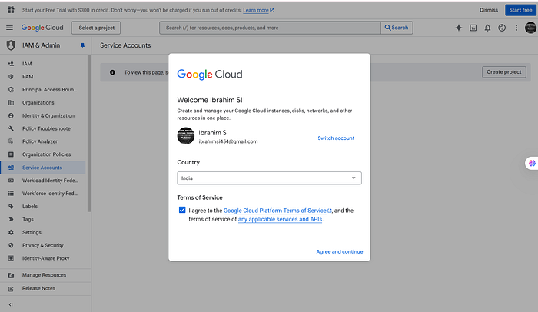

Agree and continue. Enter a project name and select the organization name after creating a project.

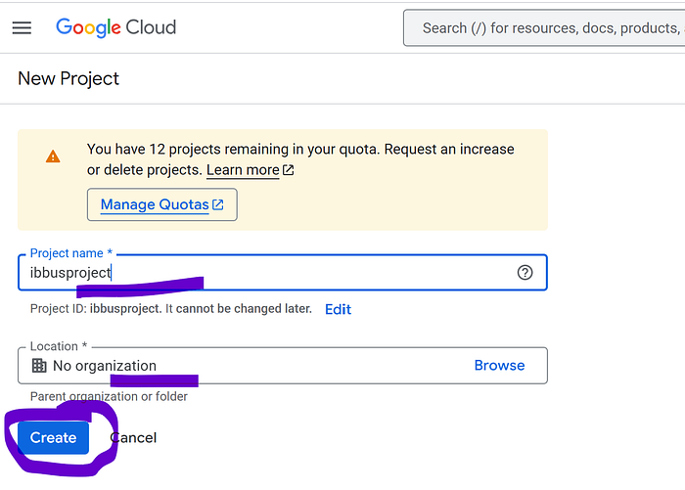

Successfully created a service account.

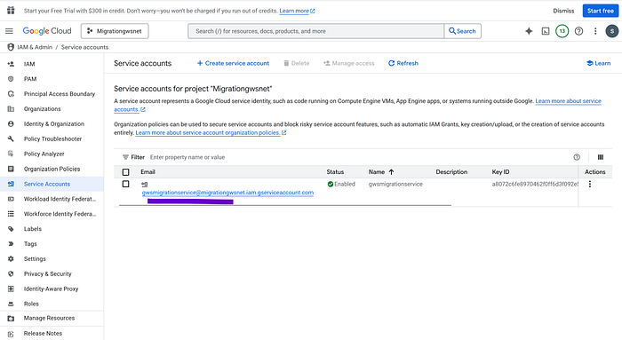

Service account → Give the Owner role.

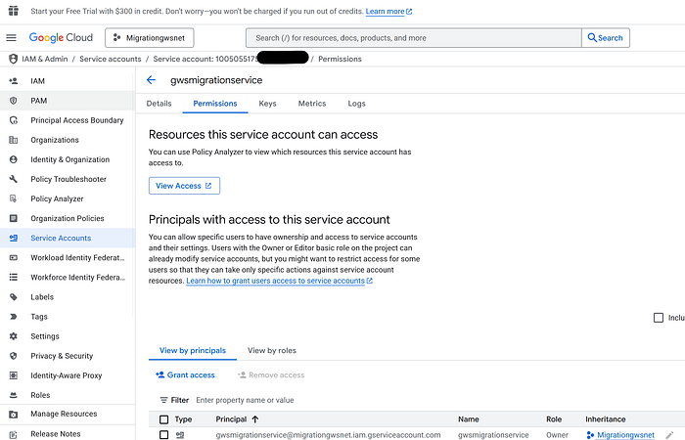

Create a new key.

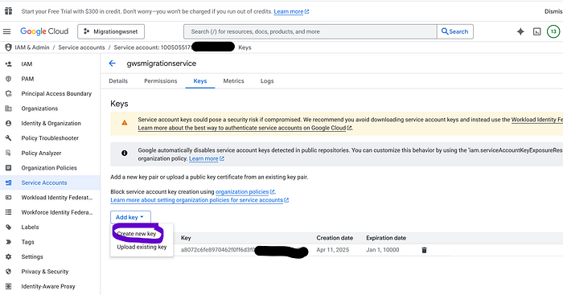

Click a JSON file and create. It automatically downloads the file.

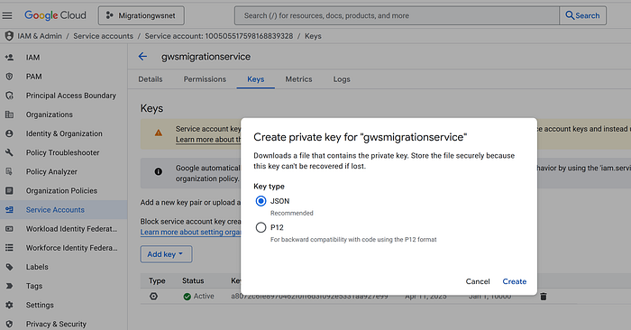

Enabling [**API Usage for the Project**](https://console.cloud.google.com/apis/library)

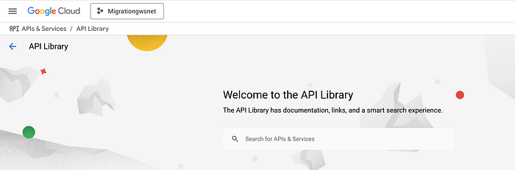

Below are examples of how to add the APIs.

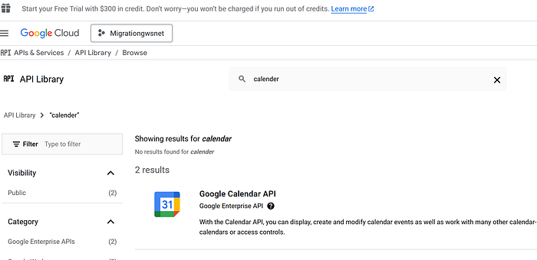

I already added the Google Calendar API.

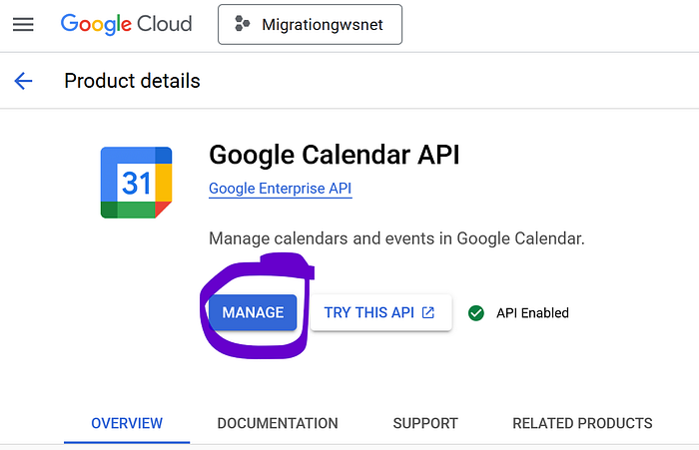

Granting access to Google tenants for service accounts. Tap Next.

Copy the service account number.

Add the below [**APIs**](https://support.google.com/googleapi/answer/6158849?hl=en).

<https://www.googleapis.com/auth/gmail.settings.sharing><https://mail.google.com/><https://www.googleapis.com/auth/contacts><https://www.googleapis.com/auth/contacts.other.readonly><https://www.googleapis.com/auth/calendar><https://www.googleapis.com/auth/gmail.settings.sharing><https://www.googleapis.com/auth/gmail.labels><https://www.googleapis.com/auth/drive><https://www.googleapis.com/auth/calendar.events><https://www.googleapis.com/auth/admin.directory.user.readonly><https://www.googleapis.com/auth/admin.directory.userschema.readonly><https://www.googleapis.com/auth/admin.directory.rolemanagement.readonly>

# **Step 3: Updating MX Records to Migrate Email from Google Workspace to Office 365**

Move to the M365 Admin Center and tap Settings → Domain.

Here, selects the domain to add an MX record and click Manage DNS.

Select an option to connect DNS and click Continue → Continue → Finish.

Your manual procedure for migration ends here.

# **Google Shared Drives and User Files Migration to M365**

Go to the SharePoint Admin Center and create a new site to serve as the destination for shared drive file migration.

How to create a [**SharePoint site**](https://support.microsoft.com/en-us/office/create-a-site-in-sharepoint-4d1e11bf-8ddc-499d-b889-2b48d10b1ce8)

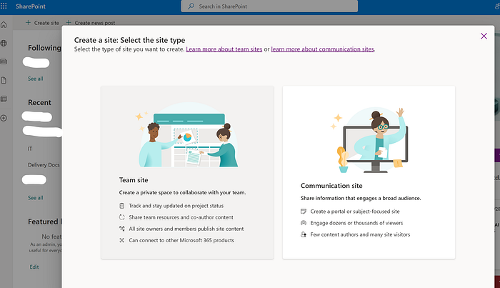

**Connecting M365 to Google Workspace for Migration**

Signed in to the M365 Admin Center, navigated to SharePoint, and clicked on it to access the SharePoint Admin Center.

From there, I clicked on Migration, which redirected me to the Migration Manager.

Next, I selected **Google Workspace** by clicking the Get Started button.

A step-by-step format

Signed in to M365 Admin Center

Navigated to SharePoint and clicked on it to access the SharePoint Admin Center.

Clicked on Migration

Redirected to Migration Manager

Select Google Workspace by clicking the Get Started button.

Zoom image will be displayed

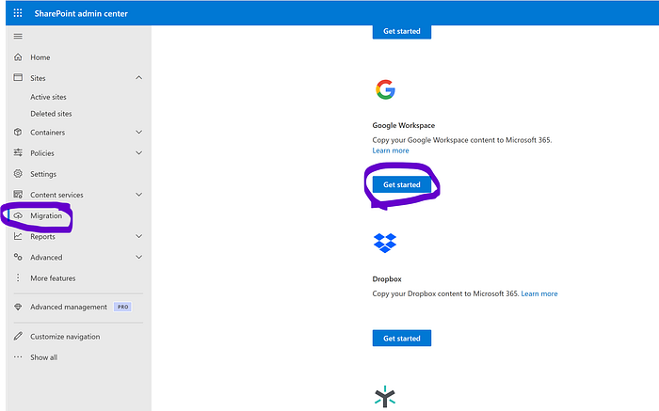

After clicking Get Started, I was redirected to the Google Drive migration page. From there, I clicked on Connect to Google Workspace to establish the connection.

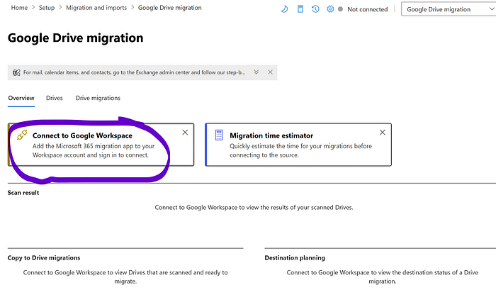

Next, installed the migration app by clicking Install and Authorize, granting the necessary permissions for the migration process.

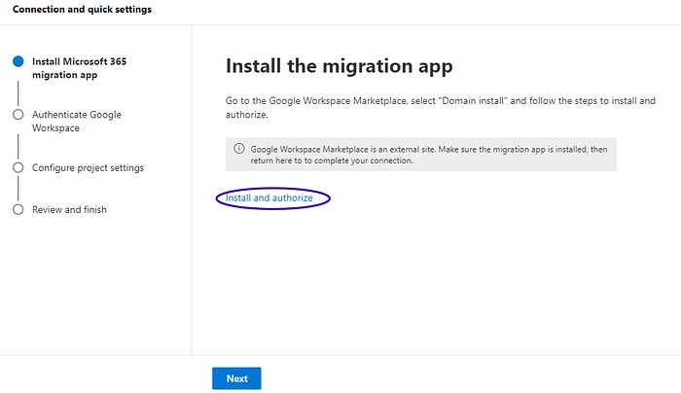

Microsoft 365 Migration package installation.

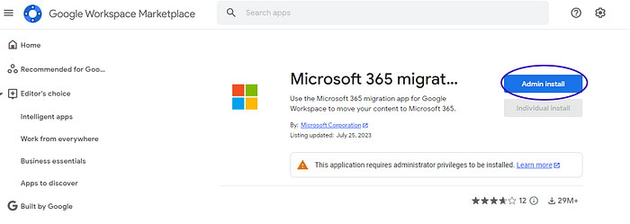

Next, I authenticated Google Workspace by entering my administrator credentials and completing the authorization process.

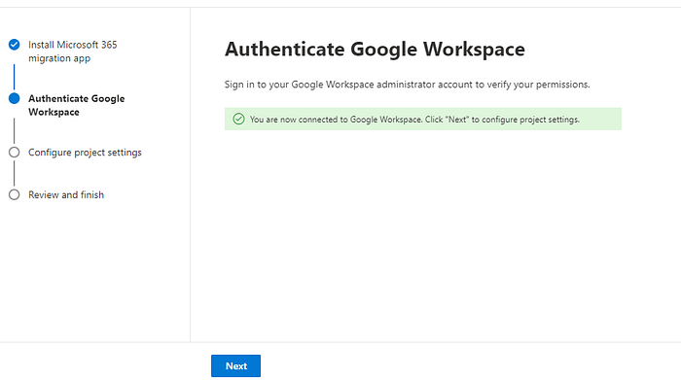

Authenticated the Google Workspace. Click Finish.

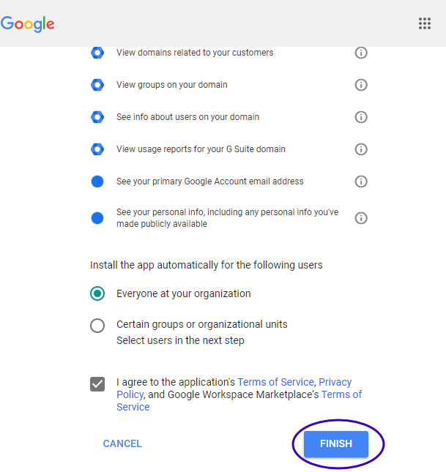

Successfully installed the 365 migrations.

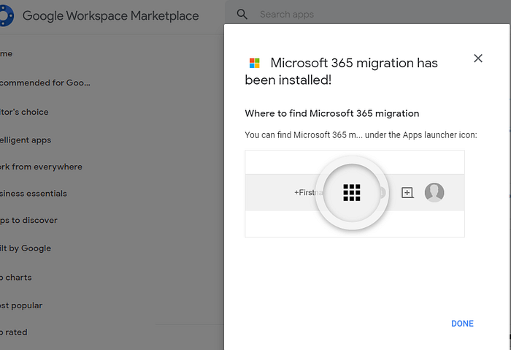

After authenticating Google Workspace, I configured the project settings and clicked Next to proceed.

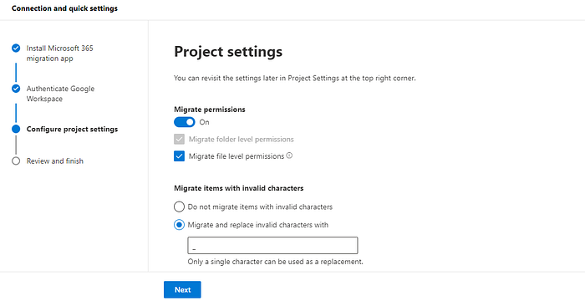

The Google Workspace migration setup is now complete, and the connection has been successfully established.

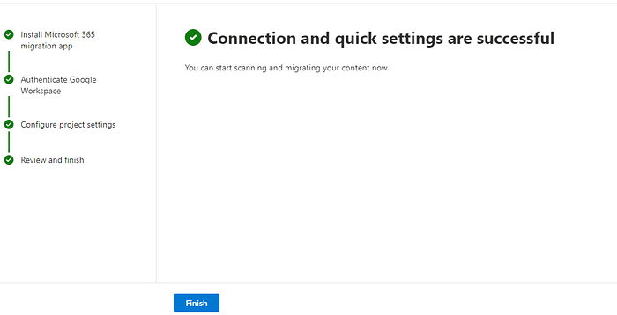

**Adding and Scanning Google Drive Folders for Migration**

At the Google Drive migration page, I clicked Add Drive.

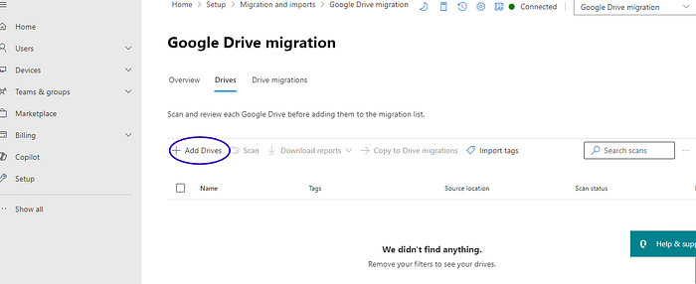

Selected All New Drive. I then checked the box next to ‘Automatically start scanning now’ and clicked the Add button.

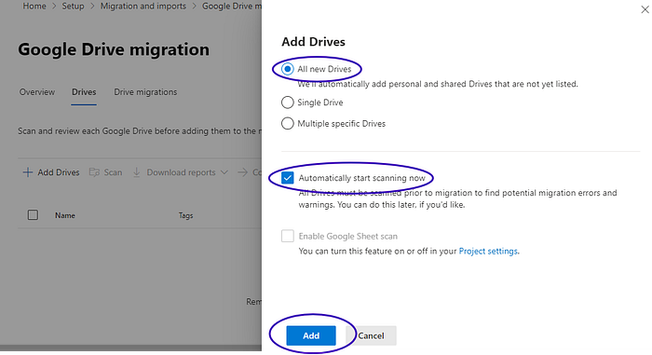

Following the successful scan, all files in the Google Workspace account were ready for migration.

To initiate the migration process in batches, I started with the shared drive named ‘Information’.

As shown in the screenshot below, this shared drive is now prepared for migration to the designated SharePoint site.

**Migrating the Shared Drive to SharePoint Online Site**

The shared drive **‘Information’** has been successfully scanned and is now ready to be migrated to SharePoint, marking the first batch of the Google Workspace migration process.

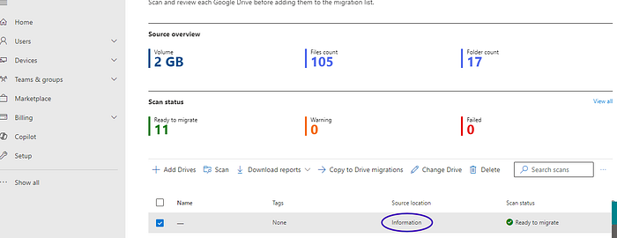

Next, I initiated the migration by clicking “Copy to Drive Migration” and selecting SharePoint as the destination path.

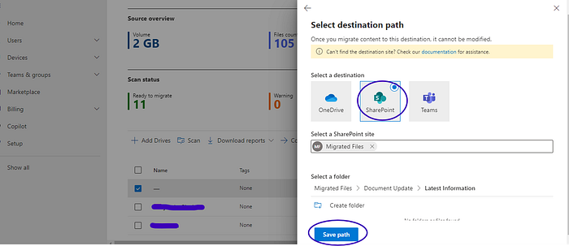

Choose the previously created site and specify the target folder within the site’s document library. I then click the “Save Path Button.”

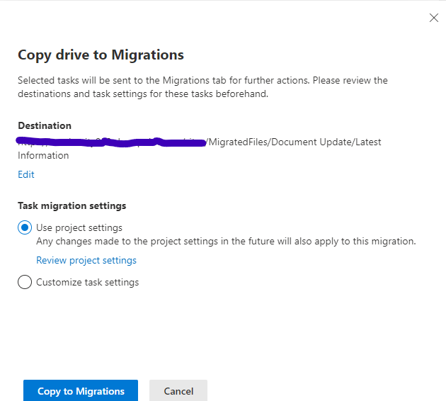

After clicking ‘Copy to Migrate’, I enabled the confirmation option and initiated the migration process by clicking ‘Migrate’.

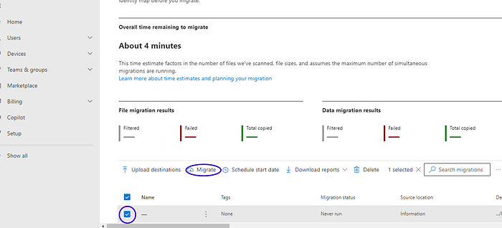

The migration process was completed successfully, with all files and data transferred without errors.

# **Direct Solution for Google Workspace to Office 365 Migration — Software**

Download, install, and launch the Sysinfo [**Google Workspace Backup Tool**](https://www.sysinfotools.com/g-suite-to-office365-migration.php)**.**

Then enter the User ID and Service Account ID of the Google Workspace you want to migrate to.

Now, click on the Browse button and add the P12 file related to your workspace account.

Then click on the Sign in with Google button, and you will be signed in to your Workspace.

Now you will have to mark the items that you want to migrate to Office 365 and click on the Next button.

Choose the Office 365 option in the Save As option.

Finally, enter the credentials of your Office 365 account and click on the login button.

The migration of Google Workspace to Office 365 process starts, and once it is completed, you will receive the confirmation report.